Homework #1 – Perceptron

Peter Olson

1/27/14

Exercise 1-3

Using a learning rate of .2, the perceptrons were taught how to recognize different letters, as opposed to the letter ‘A’. each perceptron was run for a number of epochs, until the total absolute value of all change in weights is <.1, or until 10,000 epochs if complete convergence does not occur. The results are as follows:



As you can see, some perceptrons (1=’B’, 2=’C’) fared better than others. For instance ‘H’ (7) never reached complete convergence and ran for the whole 100,000 epochs. After this it still only managed a %97.17 accuracy, as compared to the average of %98.69. Difficult letters included h, I, j, k, o and y. to some degree c and q and u also seemed to fare poorly on accuracy, precision or recall, even if they did converge.

For exercise 3 you can see the results for .05 and .8 as the learning rate. In general these both did worse, spending longer time to converge and generally lower accuracy, precision and recall. Interestingly, the .8 did have the best recall, at %99.01. This shortcoming is most likely due to the learning mechanism jumping over, or not getting to the best weights.

Exercise 4

For the ROC curves I’ve attached an excel file that has the data, and can be sorted by letter to show the roc curve. I’ve zoomed in the graph on the graph tab so that you only see from 0-0.2 and 0.8-1.0, due to the roc curves being so good!

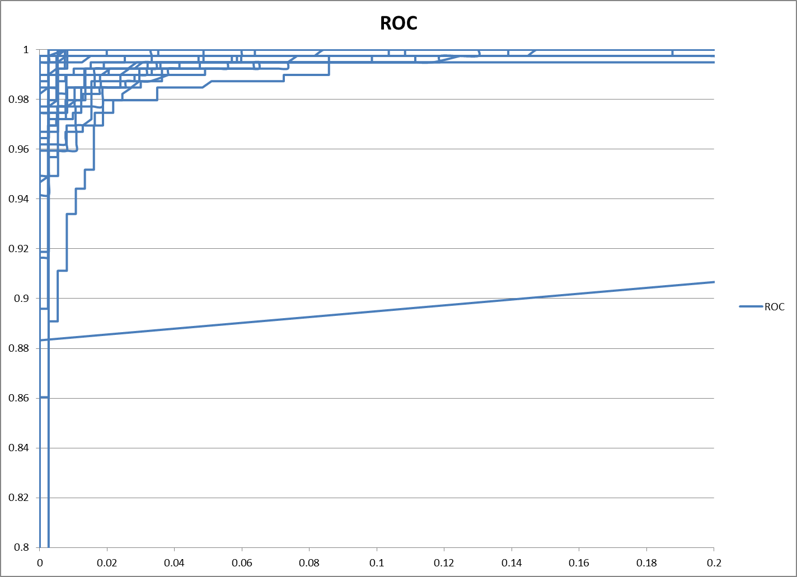

Summary

This project was really interesting, as it requited a fair amount of trust in the black box or a lot of time double checking values. In the end, the success of the perceptrons seamed to be the best measure of correctness.

Int general, the perceptrons seemed to find this a fairly easy problem. In general, the perceptrons would find a local optima within a hundred or so epochs, with very high accuracy. Pre learning the accuracy was around %50, as to be expected. However, after one or two training runs, the accuracy almost always shot up to the %96 range. This was a great indicator that the perceptrons were doing their job, and doing it well.

Some perceptrons however did not fair as well, as their change in weights never reached the <0.1 criteria, and so ran to cut off point of epochs. These perceptrons also appeared to be those that faired worse in accuracy, precision and recall (around %97), and less tight ROC curves. This most likely indicates that these letters may have some instances that are confusing when compared to “A”. however, the relatively high accuracy indicates that these might just be limited to specifically confusing examples.